Digital Signal Processing Lab

Expt. No. 5

Adaptive Line Enhancer



By Pranit Dalal

Roll no. 16EC10016

Group 22 (Tuesday)

**AIM:**

Reduction of Gaussian noise in a sinusoidal signal using Adaptive Line Enhancer (ALE).

**THEORY:**

An adaptive line enhancer (ALE) is used to detect a low-level sine wave of unknown frequency in presence of noise. If the input frequency changes the filter adapts itself to be a bandpass filter centered at the input frequency. The ALE is usually realized by using the so-called adaptive filter.

The most widely used adaptation algorithm is the Least Mean Square (LMS) algorithm, which uses the error signal e(n) in a feedback loop for coefficient adaptation.

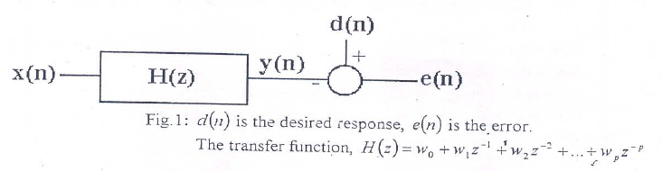

In an adaptive line enhancer, the desired response is simply the input x(n).

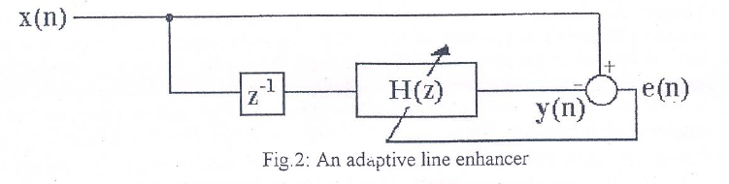

**CODE:**

Fo= 1000; % this is changed to 2,3,10Khz  
Fs= 25*Fo;  
t = 0:1/Fs:10/Fo;  
m = 2*sin(2*pi*Fo*t)+randn(size(t)); %A=2  
figure(1);  
plot(t,m);  
xlabel('time');  
ylabel('x(t)+noise');  
title('Signal contaminated with noise');  
  
mu = 10^-4;  
err_max = 10^-3;  
N=256;  
w = zeros(N,1);  
error = 1;  
x = zeros(N,1);  
x_new = zeros(N,1);  
i = 1;  
while(error > err_max) % LMS Algorithm   
 y = w'*x;  
 e = m(i) - y;  
 w_new = w + mu*x*e;  
 if(i == 1)  
 error = 1;  
 else  
 error = (sumsqr(w_new-w))/(sumsqr(w));  
 end  
 w = w_new;  
 x(1) = m(i);  
 for k = 2:N  
 x_new(k) = x(k-1);  
 end  
 x = x_new;  
 i = i+1;  
end  
Z=(abs(fftshift(fft(w,512)))).^2;  
f = (Fs/2)*linspace(-1,1,512);  
figure(2);  
subplot(211);  
plot(f,Z);  
xlabel('Frequency');  
ylabel('Amplitude');  
title('Adaptive Filter response');  
subplot(212);  
P=filter(w,1,m);  
plot(t,P);  
xlabel('t');  
ylabel('y(t)');  
title('Filter Output');

**PLOTS:**

F0 = 1000Hz

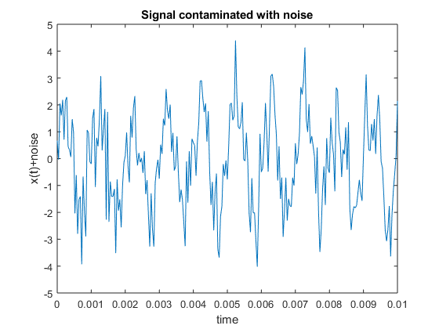

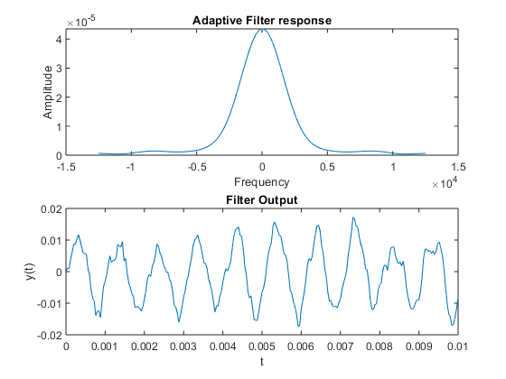

F0 = 2000Hz

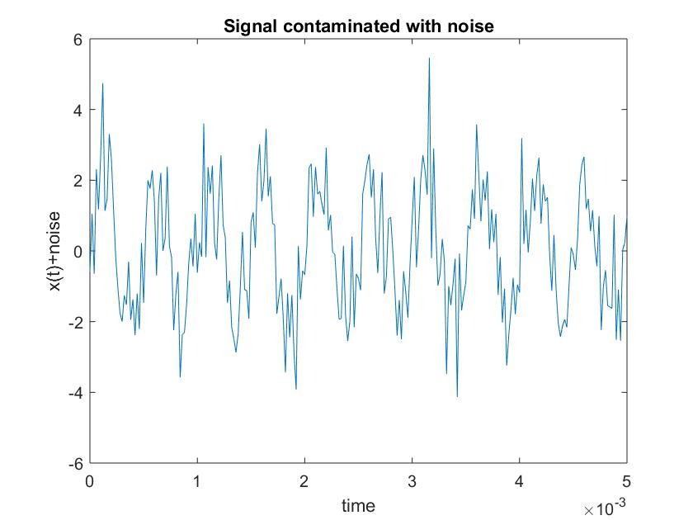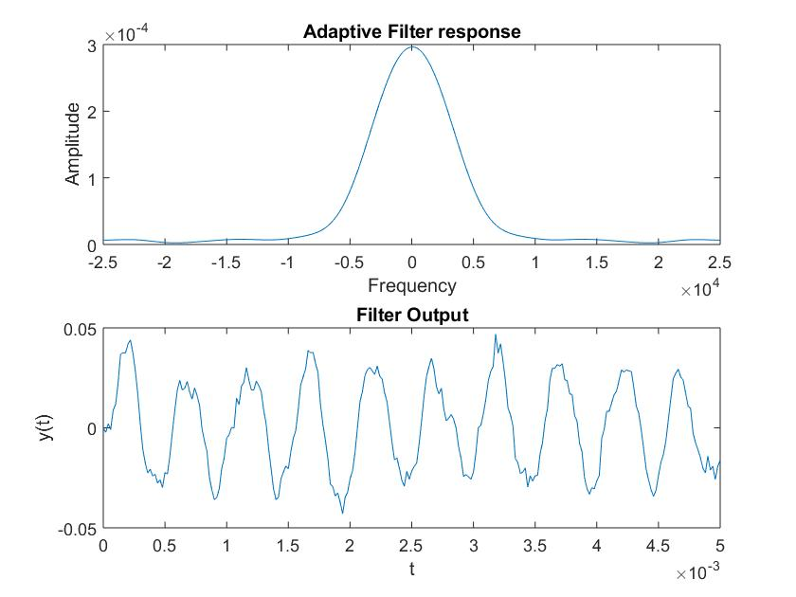

F0 = 3000Hz

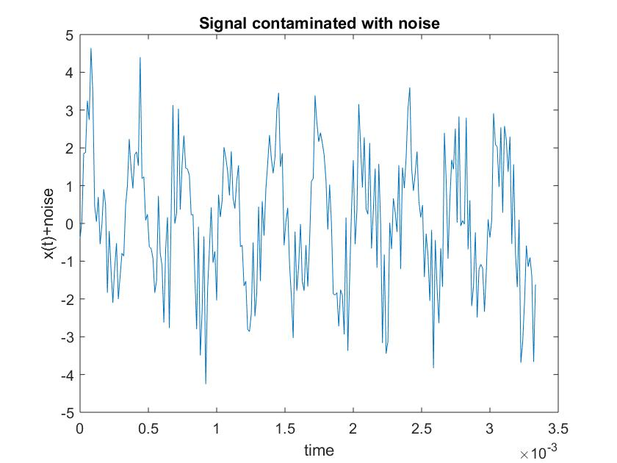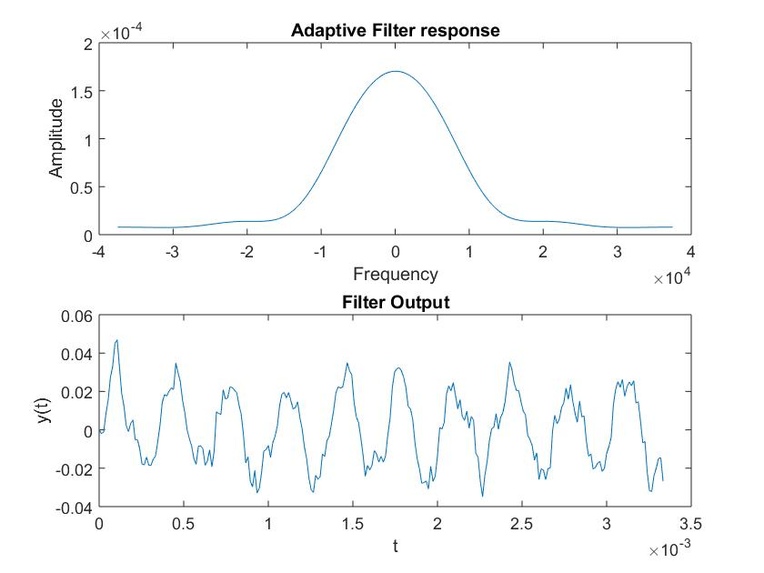

F0 = 10000Hz

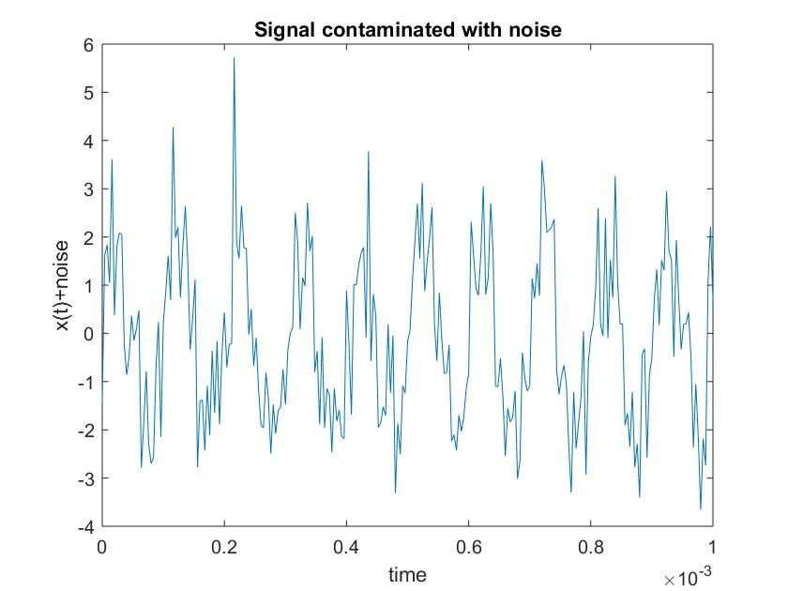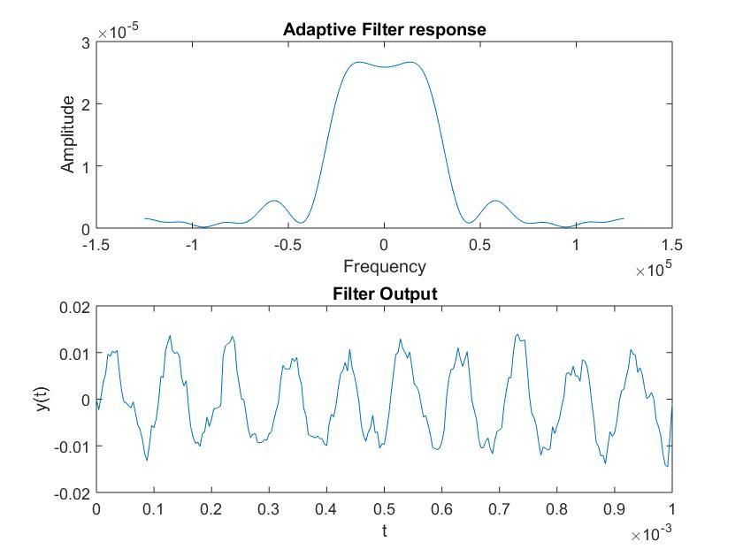

**DISCUSSIONS:**

1. We can clearly observe the filter response changing for different frequencies and also for different iteration of noise.
2. An ALE (Adaptive Line Enhancer) consists of the interconnection of delay element and a linear predictor and has an adaptive algorithm.
3. In an adaptive filter the filter coefficients are updated in time by using an adaptive algorithm so that the filter output becomes nearly same as the desired output minimizing the error. (done using LMS algorithm).
4. We can also recover high frequency signals by this method but for recovering high frequency signals we need to sample the input sequence with high sampling frequency to satisfy Nyquist criterion.
5. The filter can be interpreted as a 1-step linear predictor, i.e. it predicts the ith sample from the past i-1 samples of the signal.
6. From plots we can observe that the output signal is nearly same as the input with reduction in noise which is to be achieved in the experiment.